**GROSS INCOME**

1. **Gross Compensation Income**
2. Salary & Wages – generally, taxable

Exception:

RR 10-2008 exempts the following compensation income.

1. Compensation income of MWE in private sector and being paid the statutory minimum wage, OR
2. Compensation income of employee in the public sector with salary NOT more than the statutory minimum wage in the non-agricultural private sector.

Provided:

1. Does not receive other income such as income from conduct of trade, business or practice of profession except income subject to FT.
2. Also, does not receive additional compensation such as commissions, honoraria, fringe benefits, benefits in excess of P30,000, taxable allowances and other taxable income other than the SMW.

Otherwise, they shall be subject to income taxation on their entire income.

1. Fees – generally, taxable.

Fees paid to directors are taxed as follows

* Director is also an employee – part of Gross Compensation Income
* Director is not an employee – 10% CWT

1. Commissions – generally, taxable
2. Honoraria – generally, taxable
3. Allowances – generally, taxable

Exception:

Not part of Gross Compensation Income provided

1. Ordinary and necessary expense of employer AND
2. Employee required to account/liquidate the expenses.

The excess of advances over actual expenses constitute taxable income if not returned to the employer.

1. Holiday pay, overtime pay, night differential pay, emergency pay/hazard pay – generally, taxable
2. Sick Leave and Vacation Leave pay – generally, taxable

Exception:

The following are exempt

1. Monetized unused vacation leave credits of private employees not exceeding ten (10) days during the year.
2. Monetized value of vacation and sick leave credits paid to government official and employees.
3. Thirteenth month pay and other benefits

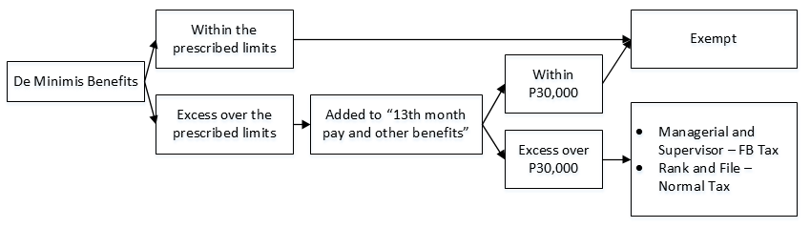

**De Minimis Benefits**

1. Monetized unused vacation leave credits of private employees not exceeding ten (10) days during the year.

2. Monetized value of vacation and sick leave credits paid to government official and employees.

3. Medical cash allowance to dependents of employees, not exceeding P750 per employee per semester or P125 per month.

4. Rice subsidy of P1,500 or one (1) sack of rice 50 kilogram rice per month amounting to not more than P1,500.

5. Uniform and clothing allowance not exceeding P5,000 per annum.

6. Actual medical assistance, e.g. medical allowance to cover medical and healthcare needs, annual medical/executive check-up, maternity assistance, and routine consultations, not exceeding P10,000 per annum.

7. Laundry allowance not exceeding P300 per month.

8. Employees achievement awards, e.g. for length of service or safety achievement, which must be in the form of tangible  personal property other than cash or gift certificate, with an annual monetary value not exceeding P10,000 received by the employee under an established written plan which does not discriminate in favor of highly paid employees;

9. Gifts made during Christmas and major anniversary celebrations not exceeding P5,000 per employee per annum,

10. Daily meal allowance for overtime work and night/graveyard shift not exceeding twenty-five percent (25%) of the basic minimum wage on a per region basis.

11. Benefits received by an employee by virtue of a collective bargaining agreement (CBA) and productivity incentive schemes provided that the total monetary value received from both CBA and productivity incentive schemes combined do not exceed P10,000.00 per employee per taxable year.

1. Separation pay

* Voluntarily availed – Taxable
* Involuntarily availed – Taxable

1. Retirement pay –generally, taxable

Exception:

Exempt if

* SSS or GSIS retirement pay
* Received under (1) RA 7641, OR (2) Reasonable private benefit plan (RPBP)

|  |  |
| --- | --- |
| **RA 7461** | **RPBP** |
| Employed continuously for 5 years – same employer | Employed continuously for 10 years – same employer |
| At least 60 at time of retirement | At least 50 at time of retirement |
| Availed only once, and only when there is no RPBP | Availed only once, no other RPBP with same OR different employer allowed.  But employee who availed of exclusion under RPBP may still claim exclusions on other grounds. |

1. Life Insurance as Compensation

|  |  |  |
| --- | --- | --- |
| **Beneficiary** | **Taxable to Employee** | **Deductible From Employee** |
| Employer | No | No |
| Employee | Yes | Yes |

1. Business Income
2. Merchandising
3. Manufacturing
4. Service
5. Farming

Accounting Methods

* Cash Basis
* Accrual Basis
* Crop Basis

1. Construction

Accounting Methods

* Completed Contract Method – will recognize income once the project is fully completed
* % of completion

1. Other Forms of Income
2. Rental Income

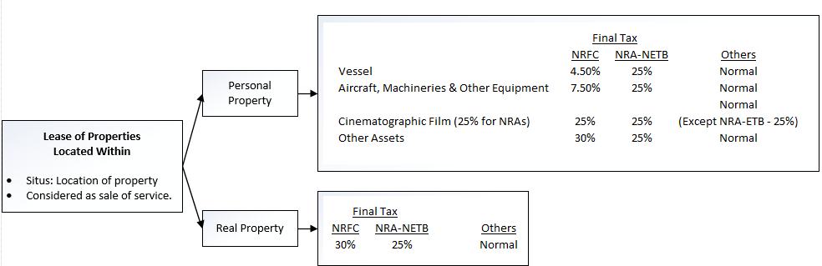

|  |  |  |
| --- | --- | --- |
| **Payments Made** | **Lessor** | **Lessee** |
|  |  |  |
|  |  |  |
|  |  |  |
|  |  |  |

1. Dividends